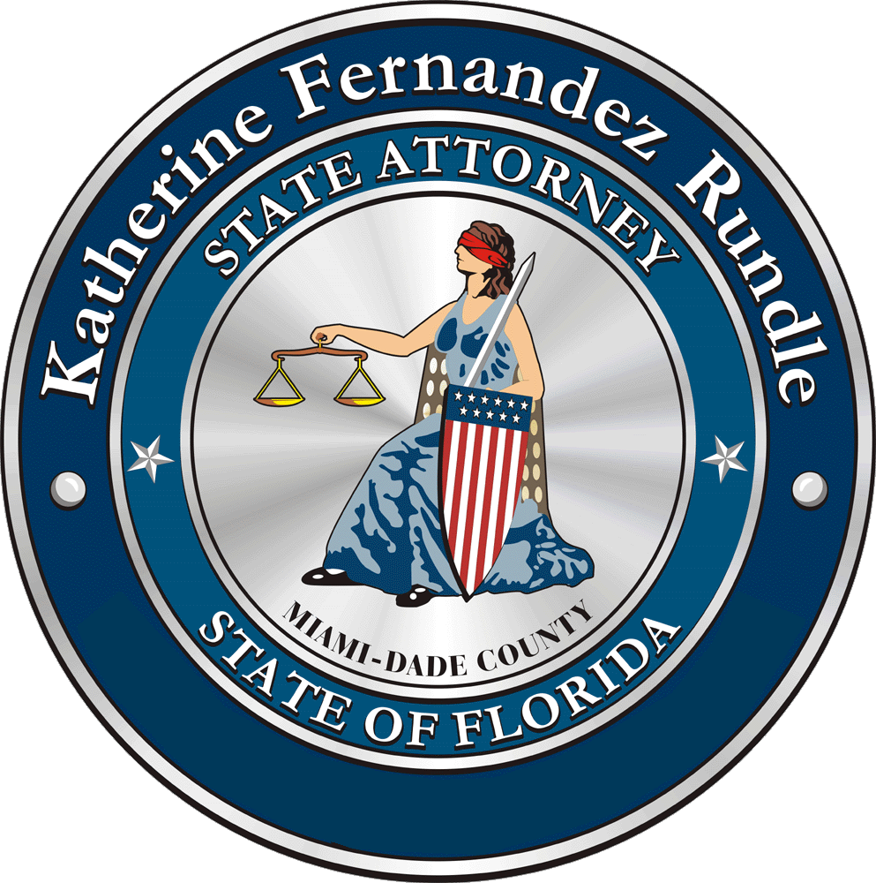 |  | KATHERINE FERNANDEZ RUNDLE  STATE ATTORNEY  ELEVENTH JUDICIAL CIRCUIT  IN AND FOR MIAMI-DADE COUNTY | 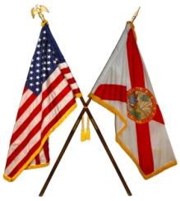
 |  | FOR IMMEDIATE RELEASE
Weston Meat Exporter Arrested
Fake invoices used in Export-Import Bank fraud

Miami (July 21, 2015) - As a result of a joint investigation by the Miami-Dade State Attorney’s Office and the Inspector General’s Office of the Export-Import Bank of the United States, 61 year old Weston resident Carlos Hernan Del Valle has been arrested for his alleged role in a scheme to defraud Plus International Bank of Miami and the Export-Import Bank of the United States of $750,000. Mr. Del Valle was arrested by Broward County Sheriff’s Deputies and Special Agents of the Inspector General’s Office of the Export-Import Bank on a Miami-Dade County warrant.

Carlos Hernan Del Valle has been charged with:
- 1 count Grand Theft 1st Degree Felony
- 1 count Organized Fraud 1st Degree Felony

“Sophisticated white collar crimes appear radically different from burglaries and armed robberies”, commented Miami-Dade State Attorney Katherine Fernandez Rundle. “But they have one thing in common: they are acts undertaken to steal from others; from home owners, from citizens or, in this instance, from our government. This was a complex crime investigated by dedicated investigators from the Office of the Inspector General for the Export-Import Bank and worked by my prosecutors. I am proud to be a part of such a law enforcement partnership.”

Mr. Del Valle, through his company Lion Trading Corporation, represented that he sold and shipped meat products to nine businesses in the Dominican Republic from November 17, 2011 through January 23, 2012. To facilitate his export business, Mr. Del Valle applied for and received a line of credit totaling $750,000 from the Miami-based Plus International Bank, a lender who specializes in international trade finance.

Based on an investigation, it is alleged that Mr. Del Valle submitted fraudulent sales and shipping documents to Plus International Bank purporting to support exports that never occurred in order to receive the funds. It is believed Mr. Del Valle used the fraudulently obtained funds to pay off earlier loans.

Weston Meat Exporter Arrested
Page 2

The Plus International Bank loan to Mr. Del Valle was insured by Export-Import Bank of the United States through an insurance program supported by U.S. taxpayers and intended to help facilitate international trade. The Export-Import Bank is an independent federal agency and is the official export credit agency of the United States. Export-Import Bank helps create and maintain U.S. jobs by filling gaps in private export financing.

#####

